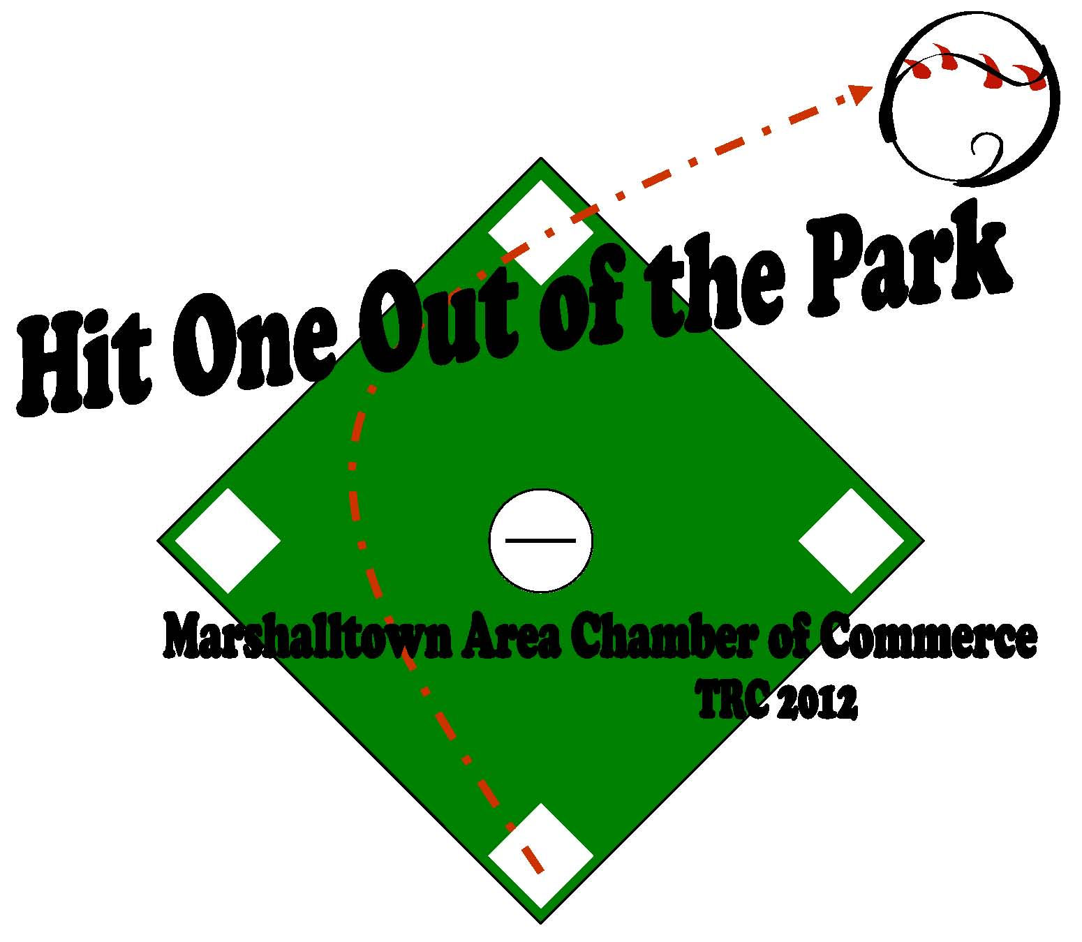
Corporate Sponsor Contract

Marshalltown Area Chamber of Commerce
709 South Center Street – PO Box 1000
Marshalltown, IA 50158
Fax: 641-752-8373
lolberding@marshalltown.org

Sponsorship

Name of Sponsorship______________________________________________________

Sponsorship Level ___

Sponsor Information

Company________________________________________________________________

Authorized Representative__________________________________________________

Billing Contact___________________________________________________________

Address_________________________________________________________________

City______________________________________State_________Zip______________

Phone____________________________________Fax___________________________

Special Instructions________________________________________________________

Amount Received $ __________________ Date Preference___________
If Applicable
Volunteer Information

Volunteer’s Name_________________________________________________________

Team ___________________________________________Date____________________

Approvals/Confirmations (must be signed by company representative)

Company Representative___________________________________________________

